**Project Development Phase**

**Delivery of Sprint 4**

|  |  |
| --- | --- |
| Date | 15 November 2022 |
| Team ID | PNT2022TMID47483 |
| Project Name | Project –Gas leakage monitoring and alerting system for industries |
| Marks | 20 marks |

Step 1: Open Node Red from IBM Cloud

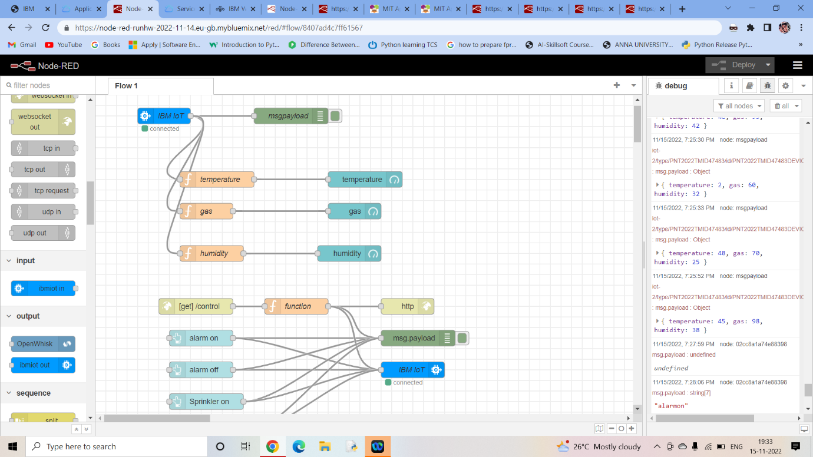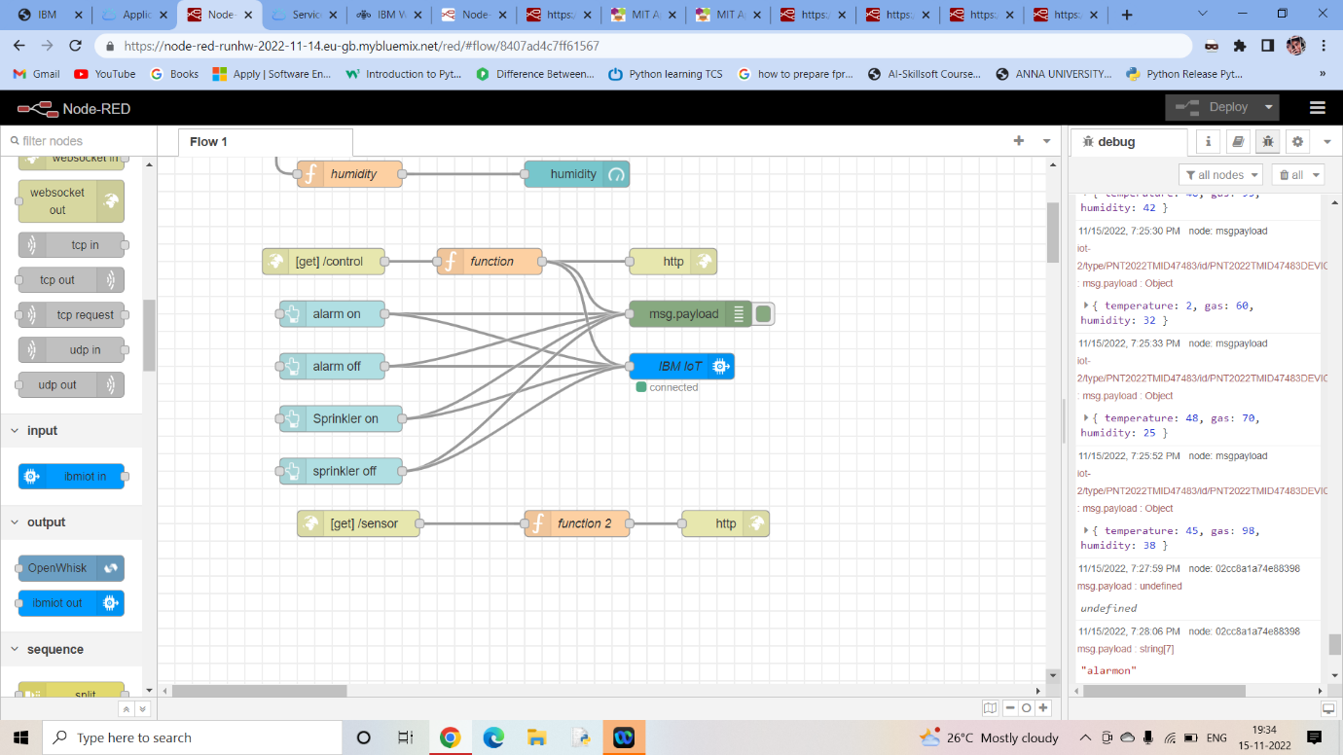

Step 2: Generated link is pasted

<https://node-red-runhw-2022-11-14.eu-gb.mybluemix.net/sensor>

<https://node-red-runhw-2022-11-14.eu-gb.mybluemix.net/control?command=alarmon>

<https://node-red-runhw-2022-11-14.eu-gb.mybluemix.net/control?command=sprinkleron>

<https://node-red-runhw-2022-11-14.eu-gb.mybluemix.net/control?command=alarmoff>

<https://node-red-runhw-2022-11-14.eu-gb.mybluemix.net/control?command=sprinkleroff>

Step 3: Paste the links in the sensor and button blocks and the results of blocks of backend is shown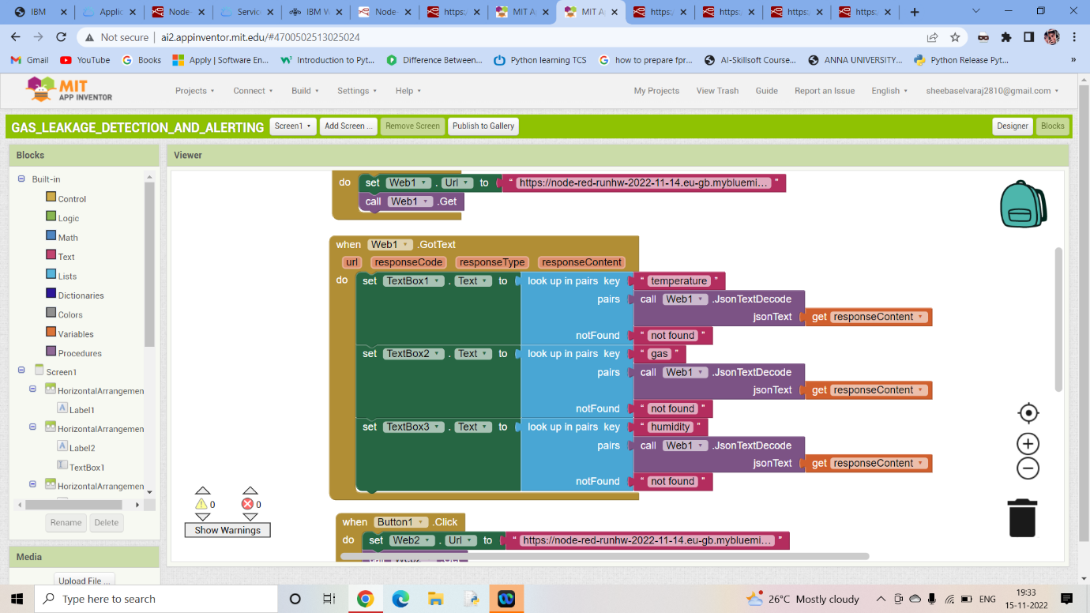

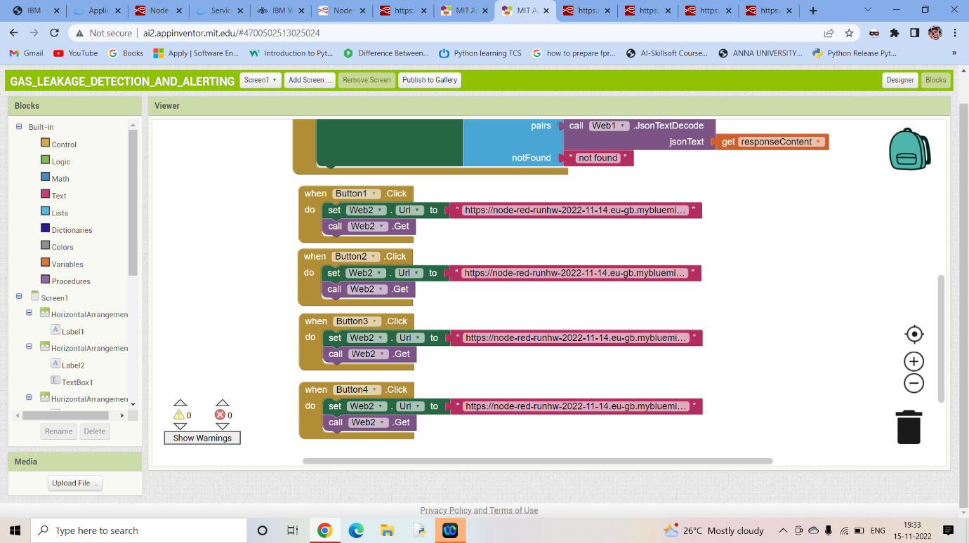

Step 4: The final input using MIT app inventor is displayed:

